目录
1.How to use 2
2. 2.General Setting 5
3. Bard Setting 8
4. Overlay 9
5.TriggerLine 11

1.How to use
The goal of this CombatRoutine development is to get a good score of 75+ in raid, and provide a lot of semi-automatic control to let you reach logs 90+ relatively easily
The current development progress of each Job (based on v0.902 version):
Bard: 90% (You can use it to challenge raids now)
Machinist: 50% (Early Testing)
Reaper: 70% (You can use it, but it's hard to get a good log90+ score)
Samurai: 20%(Another developer is working on it, and it is not yet available.)

There is currently a tool to help you automate the challenge of logs90+: TriggerLine, if you want to learn more about it, you can refer to the TriggerLine section later.

LegacyType of movement settings is highly recommended
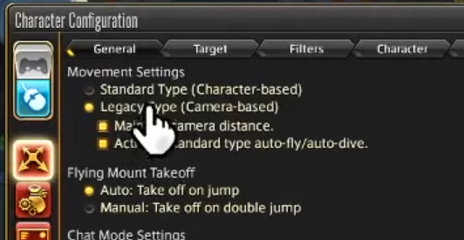

The ATB settings are best reverted to default. I'm not sure if ATB's own settings will conflict with AEAssist's logic. After all, I haven't tested it.

First, place the unpacked AEAssist into the Routines directory in Rebornbuddy
If there is an old version, remember to delete it completely.
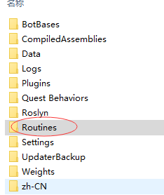
Choosed ATB mode and AEAssist,then click start,you will see the follow overlay:

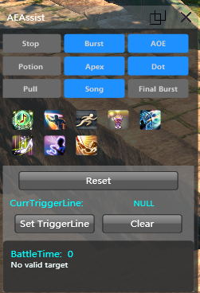

If the current job is bard/reaper/mch:
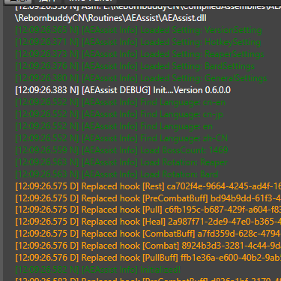
And if not,you can see “Xxx is not supported”

2.General Setting
When you open the setting window:
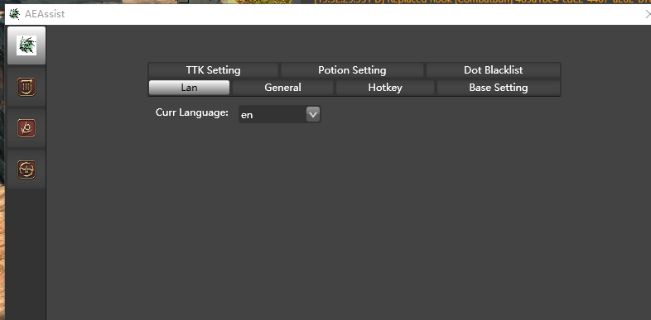

The 3 icons in the red circle in the upper left corner represent:
General Setting
Bard Setting
Reaper Setting

GeneralSetting:
(1)Lan: For en users, the only recommended option is en,If you are using a jp or other language client, please try to add config file like “AEAssist/Resources/Lan_en.json” in the same directory.
- General:

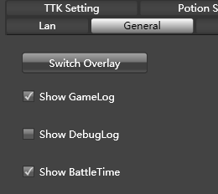

Switch Overlay: Show or hide overlay

Show Gamelog: When checked, routine will print skill usage/character lines and such in rb's log
Show Debuglog: Don't check it unless necessary. This is used to Debug
Show BattleTime: Displays the time elapsed since the start of the battle instead of the local time

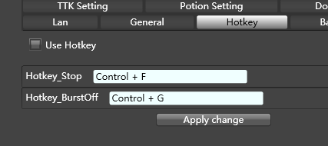

Hotkey control for stop and burst.

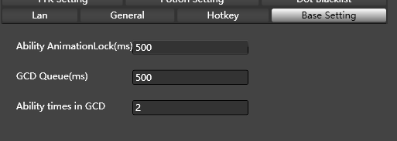

Ability AnimationLock:Estimate the animation duration of each Ability spell, if your latency is high, you can adjust it to 0, at the cost of a slight increase in cpu consumption.
GCD Queue: It is not recommended to modify it!!!
Ability times in GCD: If your network latency is high, please set it to 1
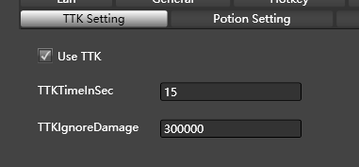
Time to kill.
Sometimes your enemy is about to die, and you don't want to continue using Dot or Burst on it.
TTKTimeInSec: How many seconds for the enemy to die
TTKIgnoreDamage: Some very large damage is not counted in the TTK calculation.

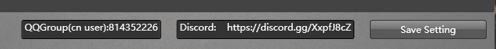

Don't forget to click SaveSetting, when you make some changes.

Bard Setting
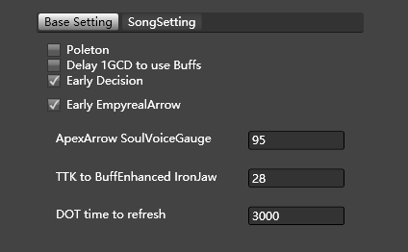

Delay 1GCD to use buffs: By default, the use of battle voice will be delayed by one GCD compared to RagingStrikes.With this option checked, it will delay by 2 GCDs.
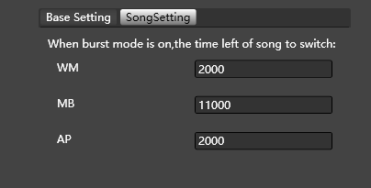

If the burst mode is off, then each song will last 45 seconds before switching to the next one. The default switching order is WM->MB->AP

Overlay

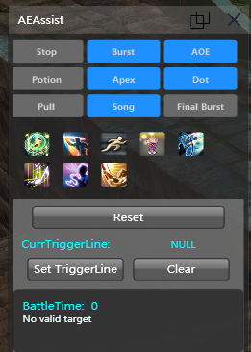

Stop: Clear the selection of the current target and stop the action.
Burst: if it is off, for bard, barrage,battle voice,radiant final and ragingstrikes will not be used
Reset: All Toggles are reset to their default state except Potion.
Pull: By default, the target will only be attacked when the countdown(Battle commencing) is complete, or if the target is attracted to any unit. When this option is checked, your character will actively attack the current target.
FinalBurst: for bard,apex will use if soul value >=20,pitch perfect will use if repertoire>=1.
Set TriggerLine: Please see the next section.

5.TriggerLine
In different dungeons, you need to control the on/off of burst, aoe, apex, dot and other Toggle, or the use of some Spell, depending on how long the battle has passed, whether the current Phase is 2/3/4, or which skill the enemy is casting.
Triggerline was developed to help you automate all of this.
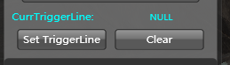

CurrTriggerLine: default is NULL, you can click “Set TriggerLine” to load a json format file.
Clear: Clear the currently used Triggerline
This json format file is exported through AETriggers.exe:

You can use AETriggers to export the following Excel file
For more details, you can open this Template file to learn how to edit the TriggerLine.
It is very simple. No programming experience is required!

